Table of Contents
Executive summary 2
1. Introduction and business value 3
2. Personal contribution: voice recognition TinyML 3
3. Group system architecture 7
4. Firmware and three-model integration 8
5. Bridge, dashboard, and data recording 10
6. Cloud deployment and Docker 11
7. Security using STRIDE 12
8. Testing and evaluation 14
9. Conclusion 15
References 15
Appendix A. Evidence map 16

TinyML IoT DemoTechnical and Business Report

Voice recognition personal contribution and group integration report

Project scope
The Arduino Nano 33 BLE Sense firmware runs three TinyML models for voice, colour authentication, and movement recognition. A Python bridge forwards the serial JSON to a Next.js dashboard with Postgres-backed session recording, Docker deployment, and STRIDE-informed API security.

Field | Value
Student | Sergey Sotskiy
Module | Internet of Things / Cloud Computing coursework
Report split | Personal section: voice recognition TinyML. The group section describes three-model integration, bridge, dashboard, Docker, and security.
Date | 29 April 2026

Executive summary

This study describes a local-first TinyML Internet of Things demo that combines edge inference, cloud-style persistence, and a web dashboard into a single demonstrable workflow. The system uses an Arduino Nano 33 BLE Sense class board to detect the start of a spoken keyword, authenticate a green colour target, and classify board movement. The board does not directly connect to the network. Instead, it prints structured JSON over a USB serial at a baud rate of 115200, and a Python bridge forwards each valid event to a Next.js API. The API stores demo sessions in PostgreSQL when Docker is used, whereas the dashboard displays the latest event, recorded sessions, authentication progress, and a movement replay chart.

Business value refers to low-cost, explainable proof-of-concept for edge sensing workflows. Voice and colour gates make the system behave like an authenticated interaction rather than a raw sensor logger, whereas movement recognition produces useful session evidence after the user has passed both gates. On-device inference reduces dependency on cloud audio processing and keeps the web layer focused on persistence, visibility, and control. Docker Compose makes the dashboard and database repeatable on a server, supporting cloud-computing requirements without forcing the microcontroller to manage Wi-Fi or database credentials.

My personal contribution was the voice recognition TinyML component. I trained and validated a keyword model in Edge Impulse, assessed its validation and on-device performance, and integrated it into the firmware state machine so that confident start detection advances the system from WAITING_FOR_VOICE to WAITING_FOR_COLOUR. The group contribution merged three Edge Impulse models into one firmware build, built the serial-to-HTTP bridge, implemented session storage and replay, added Docker deployment, and applied a STRIDE-based security layer with bearer-token protected ingest/control APIs and HMAC-signed dashboard sessions.

1. Introduction and business value

Many IoT demonstrations stop at collecting raw sensor values. This project takes a more product-like approach wherein a device first hears a voice command, then authenticates a colour, and only then records movement. The result is a staged interaction that can be explained to nontechnical stakeholders and tested live. It demonstrates how embedded machine learning can add local intelligence to a small sensor platform, whereas a web application provides the visibility and evidence trail expected from a connected system.

The Arduino Nano 33 BLE Sense is suitable for this because it combines a microphone, an APDS9960 colour/proximity sensor, and an LSM9DS1 inertial measurement unit with a microcontroller capable of TinyML workloads (Arduino, n.d.-a). Edge Impulse supports training and deploying embedded models as Arduino libraries, making it appropriate for a coursework prototype where the model pipeline and firmware deployment both need to be visible (Edge Impulse, n.d.-a). The system also reflects a practical deployment constraint: the board performs local sensing and inference, but a laptop bridge handles networking and the cloud-facing dashboard.

The business value is not only technical novelty. A staged edge workflow can be adapted to access control, equipment-use logging, gesture-controlled interfaces, or training demonstrations where the system must prove that a user completed a required sequence. The dashboard records sessions, stores movement samples, and can stop a run from the browser. This creates auditable evidence for a demo, whereas Docker and PostgreSQL make the server-side repeatable and persistent, rather than a temporary local page.

2. Personal contribution: voice recognition TinyML

My personal contribution was the voice recognition stage. The purpose of this model was deliberately narrow: to identify the keyword start sufficiently strongly to trigger the next phase, while treating background speech or silence as unknown. This small scope made the model suitable for a constrained embedded device because it avoided open-ended speech recognition and instead used keyword spotting. In the complete system, this model is the first authentication gate; therefore, its output controls whether the demo remains in WAITING_FOR_VOICE or advances to colour authentication.

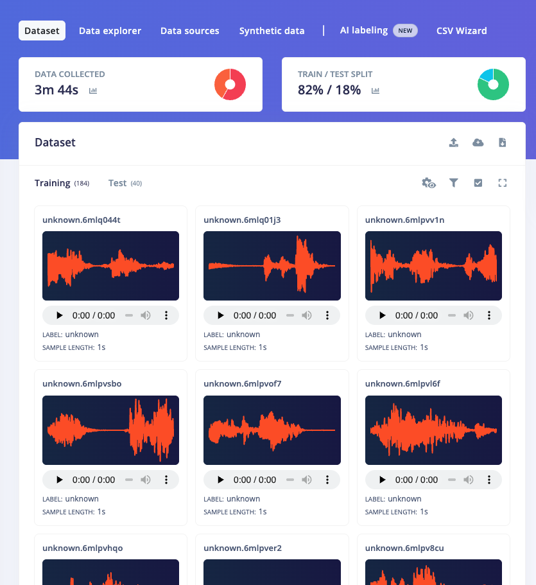

Fig. P1. Edge Impulse voice dataset showing the start and unknown classes used to train the keyword model.

The dataset was organised in Edge Impulse around the target command and a negative class. Figure P1 shows the captured voice data used for this model. The positive class represents the word start, whereas the unknown class provides classifier examples of audio that should not trigger the state change. This distinction is important because a demo environment can contain speech, movement noise, keyboard sounds, and room noise. A binary keyword model is useful only if it learns both the intended command and the non-command background distribution.

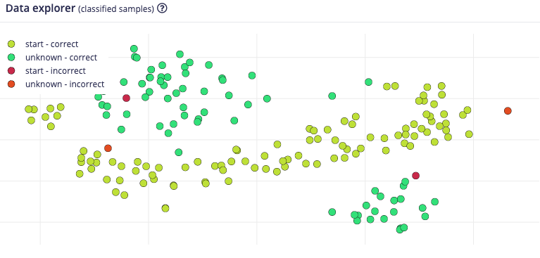

Fig. P2. The data explorer view was used to inspect the recorded voice samples before training.

Before training, the data explorer was used to check whether the recorded samples looked plausible and whether the classes were sufficiently separated for a simple audio classifier. Edge Impulse audio workflows typically transform raw audio into signal-processing features before classification, rather than feeding a full waveform directly into an embedded neural network (Edge Impulse, n.d.-b). This approach is appropriate for microcontrollers because it reduces the amount of data passed into the model and makes inference more predictable on constrained hardware. Therefore, the model fits the TinyML pattern: collect representative data, extract compact features, train a classifier, and deploy the inference code to the target.

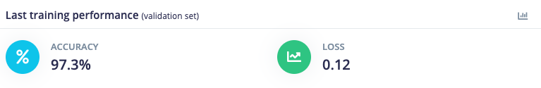

Fig. P3. Final validation performance after training the voice model.

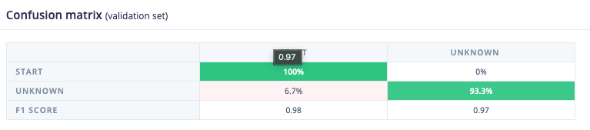

Fig. P4. Confusion matrix of the classification of validation samples.

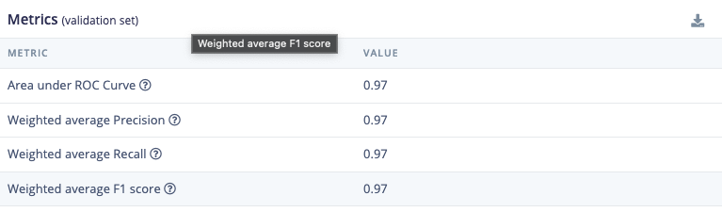

Fig. P5. Validation metrics used to evaluate voice model quality.

The validation results shown in Figures P3, P4, and P5 were used to determine whether the model was sufficiently reliable for the live state machine. The confusion matrix is particularly useful because the cost of a false positive is high: the system would skip the voice phase and immediately request colour authentication. For a demonstration, occasional false negatives are less damaging because the user can start again; however, false positives make the interaction appear uncontrolled. Therefore, the firmware also includes state-machine protections, such as an arming delay after boot and a confidence threshold before the start event is accepted.

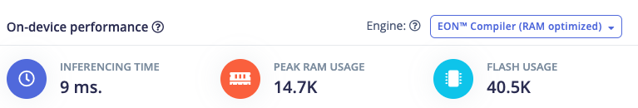

Fig. P6. On-device performance estimation for memory and latency suitability.

On-device performance was verified prior to integration. Figure P6 shows the deployment estimate used to determine whether the voice model could run within the board's memory and timing constraints. This is important because the final firmware also includes a colour model, a movement model, sensor libraries, the Edge Impulse SDK, and a serial JSON output. TinyML deployments must fit within flash and RAM and must complete inference sufficiently fast such that the user experience still feels live (Google, n.d.). Therefore, the voice model was evaluated not only for accuracy but also for whether it could run continuously on the board.

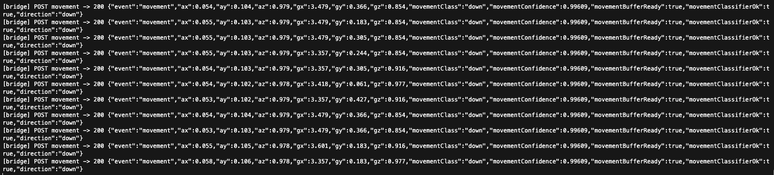

Fig. P7. Runtime bridge output showing that the deployed voice model emits voice_debug and voice_start.

After deployment, the firmware emitted voice_debug events containing the current state, threshold, arming status, streak, and classification scores. Figure P7 shows runtime evidence. The implemented threshold was 0.75, with a startup arming delay to reduce immediate false triggers. For demo reliability, the required streak was reduced to one confident detection, because earlier tests showed that demanding multiple consecutive high-confidence windows made the system miss spoken commands. This is a practical trade-off: the validation model looked capable; however, a live room, microphone placement, and speech variation can still reduce confidence. The final design maintains a high threshold, adds an arming delay, and exposes debug scores so that the operator can understand why the board advanced or not.

The main limitation of the voice component is that it was trained with a small vocabulary and a limited set of recording conditions. It should not be presented as general speech recognition. Its value is that it provides a focused, explainable trigger for a staged IoT workflow. Future improvements would include collecting more speakers, adding more negative samples from an actual demo room, testing different thresholds, and disabling the debug output once the live behaviour is stable.

3. Group system architecture

The full group system is divided into firmware, bridge, and web/cloud layers. Figure G1 shows the data flow and trust boundaries. The Arduino layer owns sensing and inference. It samples the microphone through the PDM library, reads colour data from the APDS9960 sensor, and reads acceleration and gyroscope data from the LSM9DS1 IMU. The firmware uses these inputs to run three TinyML models and prints JSON events to the USB serial port. The board is intentionally not connected to the network, keeping the microcontroller firmware simple and avoiding placing server credentials on the device.

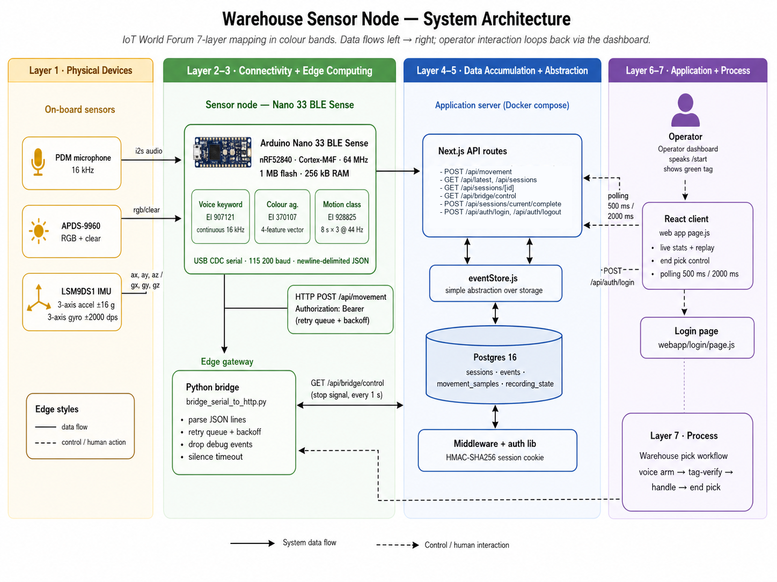

Fig. G1. End-to-end architecture showing Arduino sensing, the serial bridge, web API routes, Postgres storage, dashboard authentication, and the operator workflow.

The bridge layer runs on a laptop connected to the board. It opens the serial port at 115200 baud, ignores non-JSON lines, validates that each line is a JSON object, and posts valid payloads to POST /api/movement with BRIDGE_API_TOKEN on deployed runs. It also polls GET /api/bridge/control so that the dashboard can request a clean bridge shutdown. The bridge has a bounded retry queue with backoff for transient HTTP failures, a silence timeout for dead serial streams, and a serial reconnect retry path for USB reset or macOS device reconfiguration errors. This design was chosen because serial is reliable for the Nano board during a demo, whereas Python and HTTP are easier to debug than adding networking directly to the firmware.

The web layer is a Next.js application. Route handlers implement ingestion, latest-event, session-list, session-detail, complete-session, bridge-control, login, and logout APIs. Next.js route handlers are designed for custom request handlers in the app directory (Next.js, n.d.). When DASHBOARD_PASSWORD is configured, middleware gates the dashboard and reads APIs behind an HMAC-signed session cookie issued by POST /api/auth/login. When DATABASE_URL is configured, the event store persists data in PostgreSQL; without it, the same code falls back to memory for fast local testing. PostgreSQL was selected because session events and movement samples naturally fit relational tables with timestamps and foreign keys (PostgreSQL Global Development Group, n.d.).

4. Firmware and three-model integration

The firmware state machine has three main states: WAITING_FOR_VOICE, WAITING_FOR_COLOUR, and TRACKING_MOVEMENT. It starts in the voice state after a reset. A successful start classification emits voice_start and moves to the colour state. A successful green classification emits colour_authenticated and moves to the movement tracking state. Once movement tracking starts, the board continuously sends movement events with raw IMU values and the movement model's predicted class and confidence.

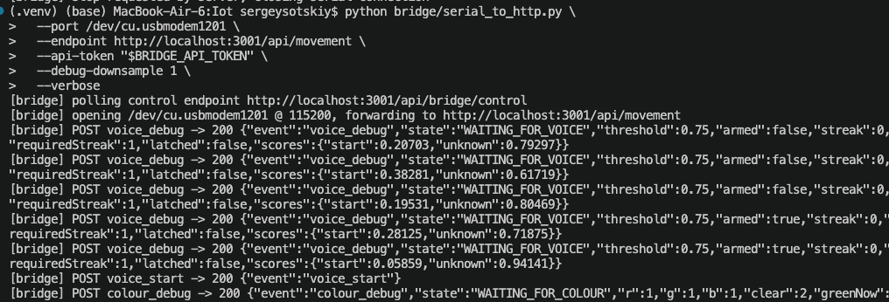

Fig. G2. Bridge output showing setup status, voice debug, and the start transition into colour authentication.

Integrating three Edge Impulse exports was the most challenging firmware issue. Each generated Arduino library expects to have only one Edge Impulse model in the sketch; therefore, including three generated inferencing headers directly creates conflicting symbols, such as run_classifier, run_classifier_init, model variables, and preprocessor macros. The solution was to create a local combined_inferencing Arduino library. It contains one SDK copy, merged model metadata, and explicit handles for the three models: voice model 970121, colour model 970107, and movement model 928825. The sketch includes only combined_inferencing.h and calls the classifier functions through the selected handle.

The colour model replaced the earlier scripted colour heuristic. The firmware reads APDS9960 red, green, blue, and clear values and maps them to the model input order ch1, ch2, ch3, and ch4. The model labels are blue, green, red and other. The firmware requires the green class to exceed a threshold of 0.70 for three consecutive reads before colour authentication succeeds. This is more robust than a single raw RGB threshold because the model can learn the teammate's recorded colour examples rather than relying only on a fixed ratio.

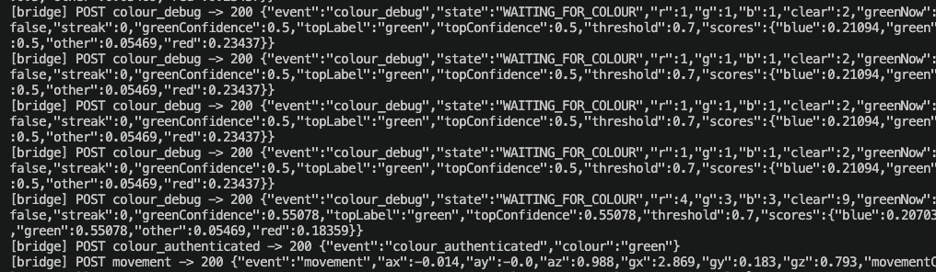

Fig. G3. Bridge output showing colour debug, green tag authentication, and transition into movement tracking.

The movement model uses 88 accelerometer samples sampled at 44 Hz, with acceleration converted from to before inference. The labels are up, down, left, right and idle. The firmware maintains a rolling buffer, runs the model after the buffer is full, and emits movement JSON about every 250 ms. It includes both raw accelerometer and gyroscope values because raw telemetry is useful when debugging model mistakes, while movementClass and movementConfidence provide the TinyML interpretation.

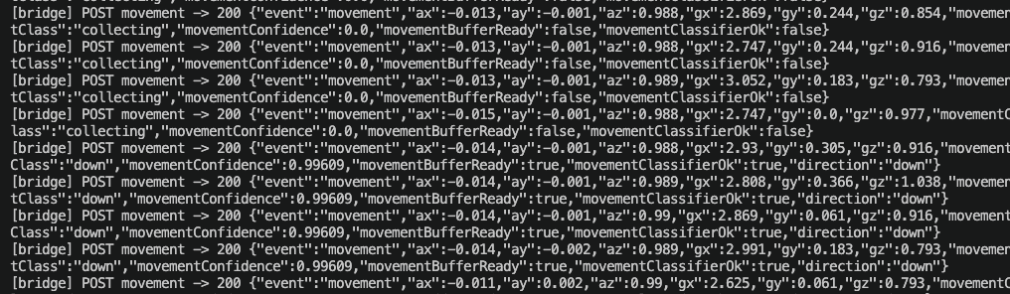

Fig. G4. Bridge output showing movement collection and classified handling direction events.

This firmware design keeps the demo explainable. Each state has one responsibility, and each state emits debug evidence while the demo is being stabilised. The trade-off is that the board state is one-way. Restarting the bridge does not reset the board; therefore, a new full demo requires a board reset to return to WAITING_FOR_VOICE. This was accepted because it maintains simple and deterministic firmware logic for a live demonstration.

5. Bridge, dashboard, and data recording

The Python bridge is the boundary between the embedded serial output and the web system. It uses pyserial to read the board, parses only lines that begin with a JSON object syntax, and uses the requests library to POST each event. Verbose mode prints the HTTP status and compact JSON payload, which makes it possible to debug the firmware sequence without opening the Arduino Serial Monitor. To keep normal sessions readable, voice_debug and colour_debug are dropped by default, unless --debug-downsample is set. Only one process can own the serial port at a time; therefore, the bridge and the Serial Monitor can not be run together.
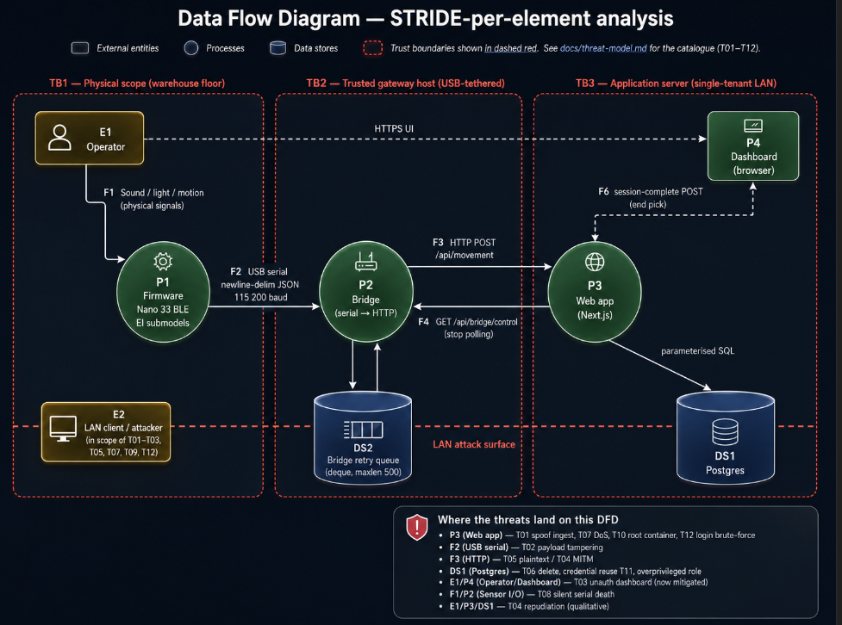
Figure G5. Firmware state machine showing setup checks, arm delay, voice gate, colour gate, movement tracking, and fault handling.

The dashboard is built around session recording rather than solely the latest event. A setup_status event starts a new session. Subsequently, voice_start, colour_authenticated, and movement events are attached to the active session. The database stores sessions, raw events, movement samples, and recording states. The movement_samples table separates chartable numeric telemetry from the raw JSON payload, whereas the events table preserves the original event for auditability. This provides the project with both a live monitor and a persistent evidence store.

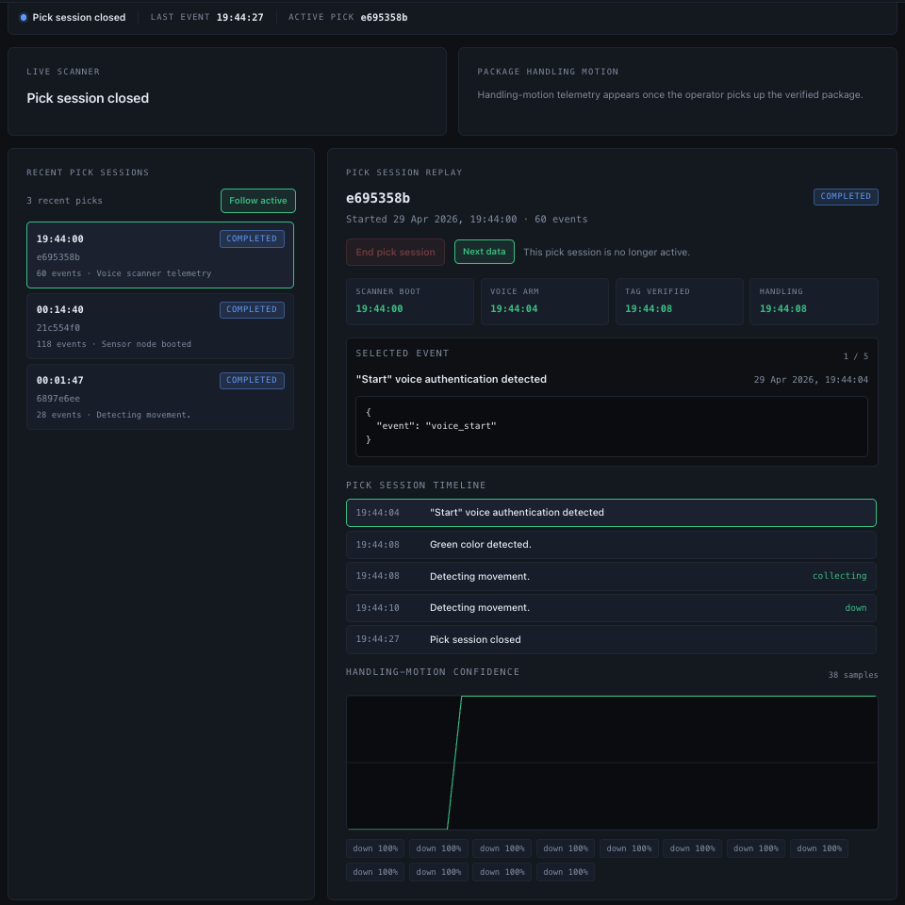

Fig. G6. Dashboard replay showing a completed pick session with voice authentication, green colour detection, movement events, and recorded-session history.

The dashboard shows business-facing status rather than only developer logs. It reports whether the voice, colour, and movement stages are waiting or complete, displays the raw latest JSON, and lists recorded sessions. The current operator-facing labels are '"Start" voice authentication detected', 'Green colour detected.', and 'Detecting movement.' The End pick session button controls the lifecycle from the web UI. When the stop action is triggered, the server accepts either the logged-in operator's session cookie or the ADMIN_API_TOKEN for external automation. If voice or colour authentication was not completed, the incomplete data is deleted because it does not represent a successful demo session. The stop action also sets the bridge control state so that the bridge exits cleanly instead of continuing to post movement samples.

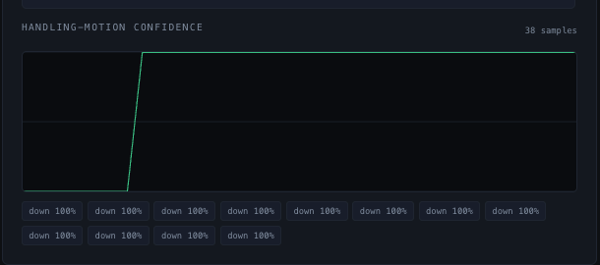

Fig. G7. Recorded movement confidence visualised in the web dashboard.

Figure G6 shows why recording sessions are more valuable than printing logs. The dashboard turns repeated movement events into a replayable chart with confidence values and timestamps. This supports post-demo analysis: the group can show that the system detected voice, authenticated colour, entered tracking, and captured movement data. For a coursework demo, this is important because it provides evidence even after the live interaction has ended.

6. Cloud deployment and Docker

The deployable server path uses Docker Compose to run the web application and PostgreSQL database. Compose is designed to define and run multi-container applications with a single configuration file (Docker, n.d.-a). In this project, the postgres service uses the postgres:16-alpine image and a named volume for persistent data, whereas the web service builds the Next.js application from web/Dockerfile. The web container runs the migration script before starting the production server; therefore, a fresh server can automatically create the required tables.

The server deployment intentionally excludes the Arduino and bridge from Docker. The bridge needs direct USB serial access to the board, so it stays on the laptop connected to the device and posts to the server URL. This separation is practical: the cloud/server part stores and visualises data, while the local laptop manages physical hardware. Docker Compose environment variables configure Postgres credentials, the public web port, and required API tokens (Docker, n.d.-b). The deployment script _update_server runs git pull --ff-only, rebuilds the containers, restarts the stack, and prints the service state.

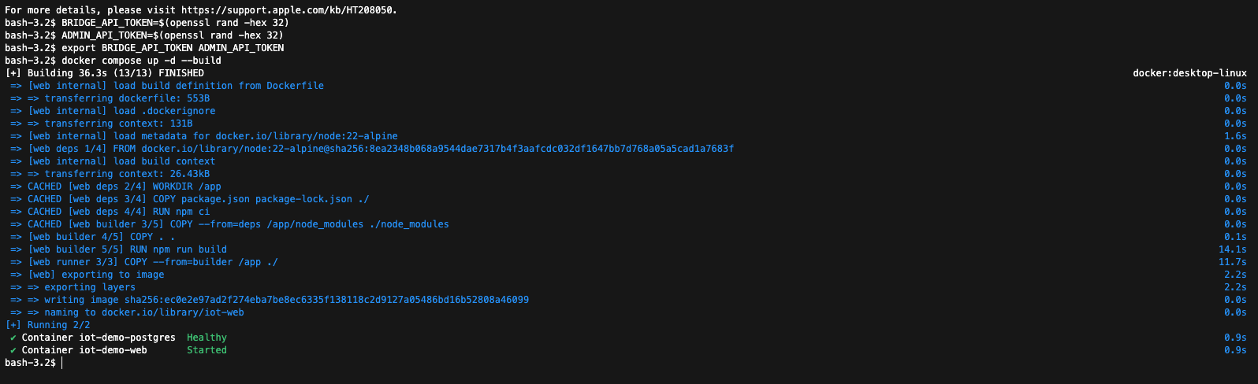

Fig. G8. Docker Compose stack running web application and database services.

PostgreSQL is not broadly exposed to the network. The Compose file binds the database port to 127.0.0.1 on the host, whereas the web container connects to it through the internal Docker network. This provides sufficient persistence and cloud-style deployment evidence for the project without turning the database into a public service. The default credentials are suitable only for demonstration and can be changed in. env before deployment.

7. Security using STRIDE

The project uses STRIDE as a lightweight security protocol and threat modelling method. STRIDE classifies threats as spoofing, tampering, repudiation, information disclosure, denial-of-service, and elevation of privilege (Microsoft, n.d.). For this system, the main assets are sensor events, session history, control actions, and shared secrets. The main trust boundaries are the USB serial from the board to the bridge, HTTP from the bridge/browser to the web API, and the web API to PostgreSQL inside Docker.

The implemented mitigation separates the bridge credentials from the operator credentials. POST /api/movement and GET /api/bridge/control require BRIDGE_API_TOKEN when they are configured. POST /api/sessions/current/complete accepts either the logged-in operator's HMAC-signed session cookie or ADMIN_API_TOKEN for external scripts. When DASHBOARD_PASSWORD and SESSION_SECRET are configured, the dashboard and read APIs require the operator session cookie. Bearer tokens are sent in the Authorisation header, following the standard bearer token pattern defined by RFC 6750 (IETF, 2012). On the server, token and password comparison uses Node.js crypto.timingSafeEqual to avoid simple timing leaks in equality checks (Node.js n.d.).

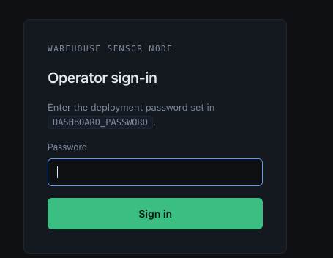

Fig. G9. The operator sign-in page is used to issue the dashboard session cookie.

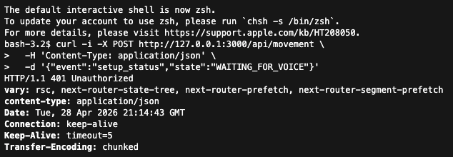

Fig. G10. An unauthorised API request returns HTTP 401 when no bearer token is supplied.

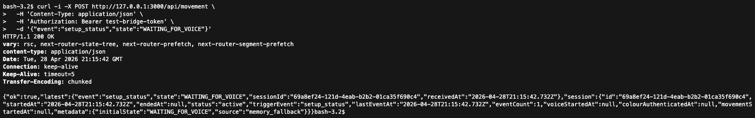

Fig. G11. Authorised API request succeeded with a valid bearer token.

Figures G8, G9, and G10 show the two authentication surfaces. The goal is not enterprise identity management but practical protection for a demo server. A random network user should not be able to fabricate board events, stop the bridge, view dashboard data when the password gate is enabled, or complete/delete sessions. The browser path uses the dashboard password and a signed session cookie; therefore, no admin bearer token is stored in localStorage.

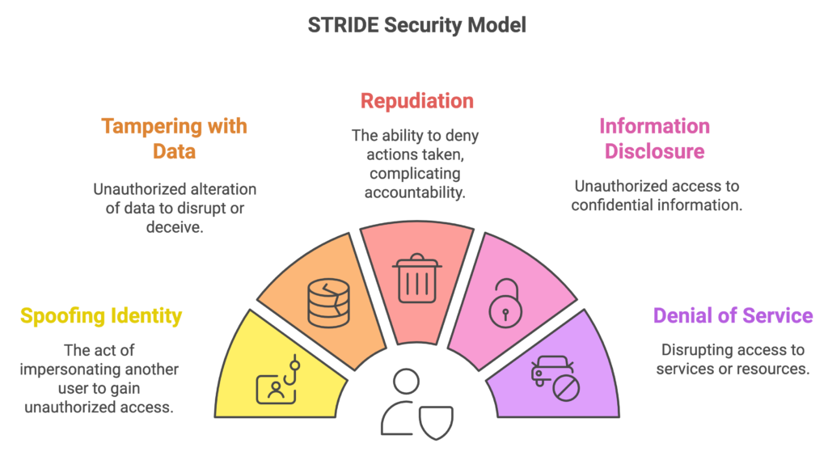

Fig. G12. STRIDE threat categories were used to structure the security analysis. Source: Practical DevSecOps (Thevarmannil, 2026).

Residual risks remain. If the server is exposed directly over plain HTTP, bearer tokens and login traffic can be observed on the network; a real public deployment should use HTTPS behind a reverse proxy. Tokens and the dashboard password are shared secrets rather than named user accounts; therefore, anyone with the relevant secret has that role. Physical access to the board and bridge laptop is trusted. These residual risks are acceptable for a university demonstration but should be addressed before a production deployment.

8. Testing and evaluation

The manual test procedure starts the web application, signs in to the dashboard when DASHBOARD_PASSWORD is configured, starts the Python bridge with BRIDGE_API_TOKEN, resets the board, and observes setup_status. The operator says start, shows a green light to the APDS9960 sensor, and then moves the board. A successful run should record voice_start, colour_authenticated, and movement events in that order. The screenshots in this report provide evidence for each phase: voice transition in Figure G2, colour authentication in Figure G3, movement classification in Figure G4, session replay in Figure G5, and movement confidence replay in Figure G6.

Figure 13. STRIDE data-flow diagram showing trust boundaries, data flows, processes, data stores, and mapped threats for the IoT demo.

API tests were also conducted. Unauthorised mutation requests return a 401 error when tokens are configured, whereas authorised requests succeed. Dashboard auth tests verify that unauthenticated users are redirected to the login page, invalid passwords fail, and valid passwords issue the session cookie used by the operator UI. Docker testing confirms that Compose starts both services and that migrations are completed before the web server runs. The main evaluation result indicates that the system behaves as a complete pipeline: local TinyML inference controls state transitions, the bridge reliably forwards JSON, the web app stores and visualises sessions, and security controls prevent unauthorised access on the deployed path.

9. Conclusion

The project demonstrates a complete TinyML IoT workflow rather than a disconnected model or a raw sensor dashboard. The integration combines voice, colour, and movement models into a single firmware state machine. The Python bridge, Next.js dashboard, PostgreSQL storage, Docker deployment, bearer-token bridge security, and signed dashboard sessions turn the board output into a deployable recorded-session system.

The strongest business value is explainability. A stakeholder can monitor the system ’sprogress from voice command to colour authentication to movement tracking and then review the captured session afterwards. Future work should improve the dataset size for all models, add HTTPS for public deployment, replace shared tokens with named users, and reduce debug output once the demo is stable. Even with these limitations, the current prototype demonstrates how low-cost edge AI can be connected to a cloud-style evidence and control layer.

References

Arduino (n.d.-a) Nano 33 BLE Sense. Available at: https://docs.arduino.cc/hardware/nano-33-ble-sense/ (Accessed: 28 March 2026).

Arduino (n.d.-b) Arduino_APDS9960 library. Available at: https://github.com/arduino-libraries/Arduino_APDS9960 (Accessed: 4 April 2026).

Arduino (n.d.-c) Arduino_LSM9DS1 library. Available at: https://github.com/arduino-libraries/Arduino_LSM9DS1 (Accessed: 6 April 2026).

Docker (n.d.-a) Docker Compose documentation. Available at: https://docs.docker.com/compose/ (Accessed: 6 April 2026).

Docker (n.d.-b) Interpolation: Docker Compose environment variables. Available at: https://docs.docker.com/compose/how-tos/environment-variables/variable-interpolation/ (Accessed: 6 April 2026).

Docker (2022) How to use the Postgres Docker Official Image. Available at: https://www.docker.com/blog/how-to-use-the-postgres-docker-official-image/ (Accessed: 7 April 2026).

Edge Impulse (n.d.-a) Run Arduino library. Available at: https://docs.edgeimpulse.com/docs/run-inference/arduino-library (Accessed: 8 April 2026).

Edge Impulse (n.d.-b) Sound recognition. Available at: https://docs.edgeimpulse.com/docs/tutorials/audio-classification (Accessed: 8 April 2026).

Google (n.d.) LiteRT for Microcontrollers. Available at: https://ai.google.dev/edge/litert/microcontrollers/overview (Accessed: 9 April 2026).

IETF (2012) RFC 6750: The OAuth 2.0 Authorisation Framework: Bearer Token Usage. Available at: https://www.rfc-editor.org/rfc/rfc6750 (Accessed: 10 April 2026).

Mermaid (n.d.) Flowcharts syntax. Available at: https://mermaid.js.org/syntax/flowchart.html (Accessed: 11 April 2026).

Microsoft (n.d.) Threats: Microsoft Threat Modelling Tool. Available at: https://learn.microsoft.com/en-us/azure/security/develop/threat-modelling-tool-threats (Accessed: 11 April 2026).

Next.js (n.d.) Route Handlers. Available at: https://nextjs.org/docs/app/getting-started/route-handlers-and-middleware (Accessed: 12 April 2026).

Node.js (n.d.) Crypto: crypto.timingSafeEqual. Available at: https://nodejs.org/api/crypto.html#cryptotimingsafeequala-b (Accessed: 12 April 2026).

PostgreSQL Global Development Group (n.d.) PostgreSQL documentation. Available at: https://www.postgresql.org/docs/ (Accessed: 12 April 2026).

Appendix A. Evidence map

Evidence | What it proves
Figures P1-P7 | Personal voice of a TinyML workflow, validation, on-device feasibility, and deployed runtime output.
Figures G1-G6 | end-to-end architecture, firmware state transitions, bridge forwarding, dashboard session recording, and movement replay.
Figure G7 | Docker Compose deployment path for the web app and PostgreSQL database.
Figures G8-G11 | Dashboard login and STRIDE-inspired API protection with unauthorised and authorised request outcomes.

